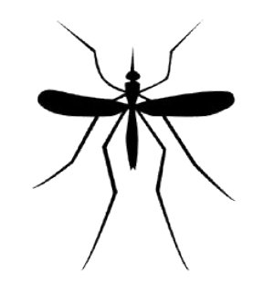
Mosquito Surveillance and Virus Updates from 7/25-8/5
Berks County Conservation District West Nile Virus Program

Areas Surveyed:

- Reading City
- Wyomissing Boro
- Cumru Township
- Kenhorst Boro
- Muhlenburg Township
- Ontelaunee Township
- West Reading Boro
- Alsace Township
- Exeter Township
- Shillington Boro
- Spring Township
- St Lawrence Boro
- Bern Township
- Bethel Township
- Upper Bern Township
- Penn Township
- Oley Township
- Douglass Township
- Bechtelsville Boro
- Bally Borough
- Washington Township
- Hereford Township
- Strausstown Boro
- Jefferson Township
- Maxatawny Township
- Longswamp Township
- Topton Borough
- Richmond Township
- Fleetwood Borough
- Maidencreek Township
- Lyons Borough
- Mohnton Borough

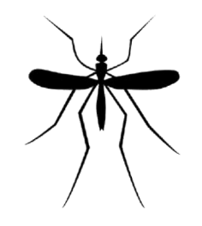
*Areas underlined are surveyed each week
**Areas in red indicate a positive mosquito sample**

Testing Results:
As you can see from the above information, we have seen a rise in mosquitoes positive for West Nile Virus. The affected townships/municipalities have been notified and precautions are being taken. If there are concerns about public safety, my team and I would be willing to conduct mosquito education and/or workshops for township/municipal staff and/or residents.
**Please keep in mind that not all samples from surveyed areas have been tested at the time this letter is distributed. **

West Nile Prevention
The risk of West Nile Virus transmission is still relatively low, but we are asking that residents take the precautions listed below:
- Stay indoors during peak mosquito hours
  - Dawn to Dusk
- Wear long sleeves, pants, and closed-toed shoes if possible
  - Exposed skin may be at risk for biting mosquitoes
- Wear bug spray
  - Specifically bug spray containing at least 30% DEET
- Remove all standing water from your property
  - Birdbaths, wheelbarrows, and children’s toys can hold water which can breed mosquitoes.
  - Extra surveillance is currently being conducted in the WNV affected areas as well as larval and adult mosquito control measures. Educational opportunities are available upon request.

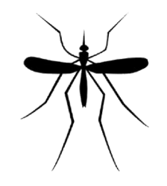
BCCD Mosquito Prevention:
When the mosquito team here at the district receives notice that a sample from the county has tested positive for West Nile, we begin to conduct further larval and adult mosquito surveillance. Our main goal is to reduce mosquito breeding by removing breeding habitat, whether through physical removal of breeding areas or through education. Residents may begin one of our team members placing door hangers on homes that explain how each homeowner can reduce mosquitoes on their property. Educational opportunities are available for any township or municipality that may be interested for both staff and/or residents.
Habitat Reduction
My team has noticed an uptick in mowing wet areas in these last two weeks. We do realize that grassy areas are growing once more due to the recent rain events, but mowing wet areas leaves behind tire ruts and puddles that breed mosquitoes. Please keep this in mind before mowing.
Another area of concern is artificial containers that are left over turned. Trash cans, trash can lids, and recycling bins for example, when left open to hold water, are prime mosquito breeding habitat.

Further Information:
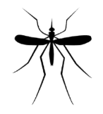
For further information on what is happening in the county, please reach out to Jolie Coates, or follow our Facebook and Instagram pages. Our social media pages are kept up to date and sharing that information to your own municipal page may be helpful to your residents.
Berks County Mosquito Team Members:
Coordinator: Jolie Coates, 610-372-4657, ext. 218, joliecoates@berkscd.com
Seasonal Technician: Josh Toth, 610-372-4657, ext. 220, joshuatoth@berkscd.com
Larval Technician: Mason Crouthamel, MDCLarvalTech@berkscd.com

